Muhammad Rafi Naufal Pratama

V3922034

TIE

Hasil Bar Chart

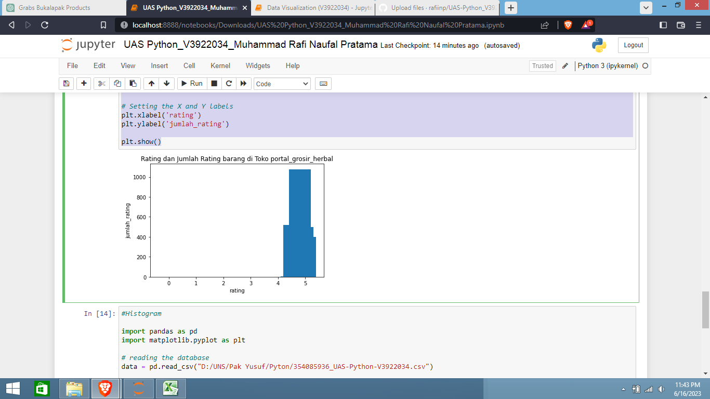

Hasil Histogram

